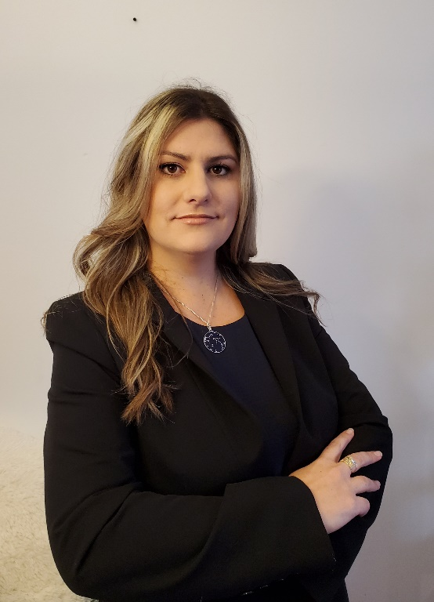
Dr. Aline Remus is a Research Scientist at the Sherbrooke Research and Development Centre (Agriculture and Agri-Food Canada). Dr. Remus completed her BSc. (2012, UFSM, Brazil), MSc. (2015, UNESP, Brazil), and Ph.D. (2018, Laval University and UNESP joint program) in Animal Science. She joined AAFC in 2014 as a master's student and got a position as a researcher in 2019. Her main research areas are amino acids and energy metabolism, nutritional physiology, amino acids and energy requirements, and environmental impacts of animal production. She published more than 30 peer-reviewed papers, 70 conference abstracts and co-authored three book chapters. She was invited speaker on 16 occasions at national and international events. She served in scientific organizing committees and editorial boards and sits on Modeling Committee of t the National Animal Nutrition Program (NANP- USA). She has received five awards or recognitions and eight scholarships for her scientific and academic achievements. For the past ten years, she has worked developing Precision Feeding and Nutrition for pigs. She makes her mission to give voice to the outliers by studying the variability in protein and energy metabolism of growing-finishing pigs.

